CB hotspots – Czech republic
Hello Simon,
I read about my CB-hotspot project on your web and i want to give you more information about it. The project started three months ago as a simple way to connect two towns together via CB radio. When my friends tried it, they offered me many other QTHs for my hotspots. So i was making a new pieces for many days and nights and today we have 41 hotspots in our reflector network.
The technology is based on SVXLINK software (i am using it on many HAM repeaters) and its feature SVXReflector. I used an Orange Pi zero (it has an onboard soundcard) and Anysecu CB-40 radios together. Everything is stored in the 3D-printed box fastened to the bottom of the radio.
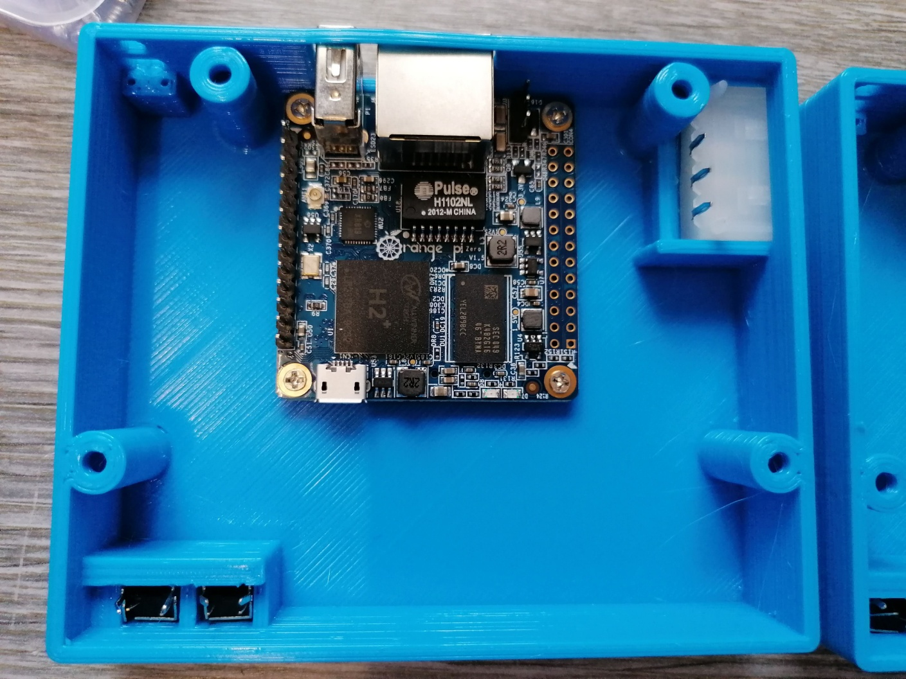
You can see it on the picture (before wiring). The switches on the left bottom side are for switching channels, because the Anysecu CB-40 radio did not have them on the body and the microphone is disconnected.
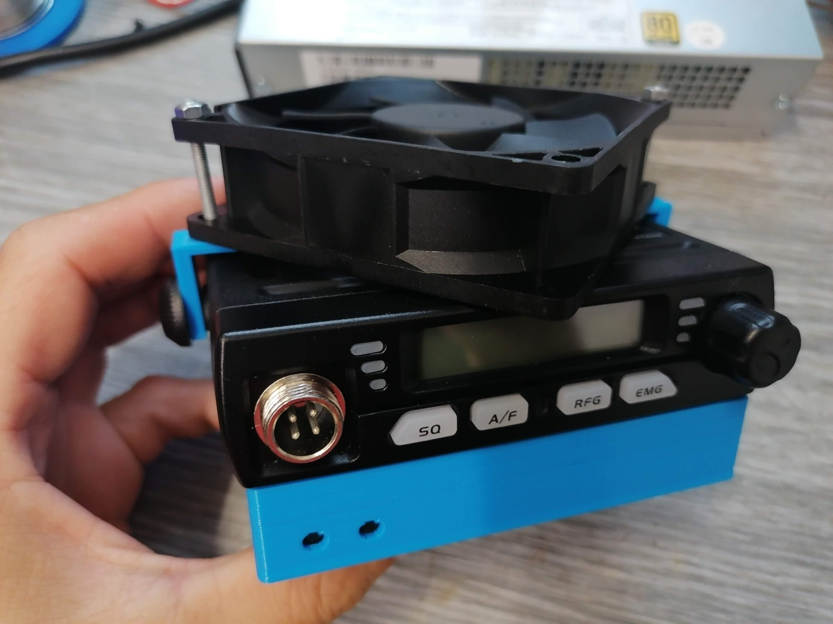
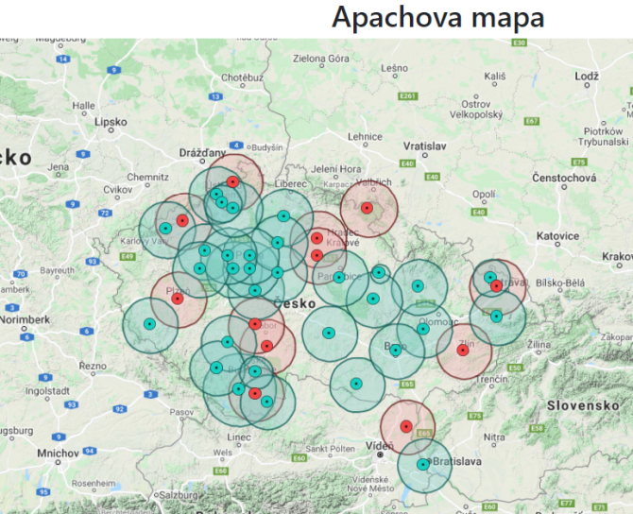
I used the SVXreflector dashboard to display all information about the reflector status. Its address is http://cbradio.ok1ocb.cz:60006 – you can see if there is anybody talking now and if all the hotspots are online. My friend made a usefull map, it is on https://www.cbpmr.info/. It shows all the hotspots which are working (green) and the planned hotspots (red).
The using of this network is very simple, but the CTCSS enabled radio is needed. I tried a classic squelch, but it was unusable during a sunny days and during the storms with lightnings – the squelch was opened too often. I set the squelch timeout to 120 seconds in case of any distortion.
We have covered a big part of our small country, so we can talk with 20 – 40 people every evening starting 7:30 PM when we have an activity time. It is nice to hear that many people met their friends from another towns after many years on the radio.

